April 2023.
- Area under the curve – distribution properties of the drug, absorption?
Plasma concentration
$Type equation here.$

- Absorption constant is independent of – extravascular route of administration, form of drug (tablets, suspension)
elimination constant

- Bioavailability increased – poor absorption, extensive presystemic metabolism
Bioavailability is increased through change route of administration

Which of the following would increase by at least 30% if taken with Lithium? – Amisulpride, Citalopram
Lithium is excreted through renal route and alters effects of drugs which are excreted through renal route such as amisulpride

- EMI – 40year old woman is unable to remember a traumatic experience – dissociative amnesia, dissociative identity disorder, dissociative neurological symptom, possession trance disorder.

- EMI – A woman is unable to remember personal identity – same options as above
dissociative identity disorder

- EMI – Regarding type of power, patient stops using a medication following a Dr’s advice – expert power, coercive power(if doctor forced the patient), information power(if doctor had shared complete effect and side effects to patient).

- EMI - Regarding type of power, Group campaign on negative effects of smoking - expert power, coercive power, information power

Legitimate power | The power held by an individual in an organisation
Referent power | The power held by a person with charisma who people gravitate towards
Expert power | The power of a person with specialist skills or knowledge
Reward power | The power of a person in a position to provide rewards
Coercive power | The power of a person who has the ability to apply negative influences such as demotion
Other terms to be aware of include:
Outcome power - the power of a person to bring about outcomes
Social power - the power of a person to influence others so that they will bring about outcomes
Counterpower - the power of the oppressed to counterbalance the elite

EMI on medical ethics – Patient on admission was found to have a suspicious mass on routine chest X-ray and the team decides not to tell him – Beneficence, Non-maleficence, Autonomy, Paternalism(when a physician or other healthcare professional makes decisions for a patient without the explicit consent of the patient)., Utilitarianism (TELEOLOGY, There are three key ethical theories which have dominated medical ethics:
- Utilitarianism
- Deontological
- Virtue based
Utilitarianism:
Founded on the work of Jeremy Bentham (1748–1832) and John Stuart Mill (1806–1873).
The greatest good for the greatest number.
It is a consequentialist theory, as it holds that the predicted outcomes (i.e. the consequences) of an action are the most morally important component of that action.
Bentham thought that humans were governed by two factors: ‘pleasure and pain’, thought it was possible to classify how good an action is by measuring how much pleasure or pain was brought about by that action. He called this process ‘felicific calculus’.
Mill differed, he thought that people should ordinarily stick to moral rules. He is still a utilitarian, because he held that these moral rules should be calculated using the principle of utility. This is what is known as rule utilitarianism . For example, lying in general might produce less utility than telling the truth. Therefore, there is a rule that says ‘Do not lie!’
The use of evidence-based medicine to produce guidelines on cost-effectiveness by organizations such as the National Institute for Health and Clinical Excellence (NICE) is utilitarian, based on ideas of what promotes the greatest good for the greatest number.
Deontological:
Deontology covers those theories that emphasize moral duties and rules, rather than consequences (from the Greek deon , meaning ‘duty’). A good example is the Ten Commandments. The General Medical Council's code of conduct, Good Medical Practice , is essentially deontological, founded on the duties of a doctor, and can be seen as a rulebook.
Deontology is associated with Immanuel Kant (1724–1804). He believed that morality was not dependent on how much happiness resulted from particular actions. Rather, he thought morality was something humans imposed upon themselves because they are rational beings.
Kant argued that we can find out which moral rules to obey by using our powers of reason. He said that by seeing whether our desires can be applied universally, we can tell whether or not they follow rational moral principles. This ‘universalizability’ test is called the ‘categorical imperative’. It states:
'act only on that maxim through which you can at the same time will that it should become a universal law'
This means that we should behave in such a way that we can imagine everyone can behave. For example, if our ‘maxim’ or ‘desire’ is to ‘steal other people's things when we want them’, we need to consider whether or not this maxim could be held for everyone.
Virtue based:
In ethical assessment, utilitarians look at the consequences of a particular act, and deontological ethicists at the conformity of the act with pre-defined rules. Virtue ethics stands in a different position: its foundation is the ethical characteristics of a person.
Certain personal characteristics are recognized as virtues and others as vices. Honesty, generosity, compassion, courage, justice, fidelity, and veracity are virtues that characterize an ethical person, while deception, selfishness, cruelty, infidelity, and disingenuousness are some of the many characteristics that denote a vicious person.
Virtue ethics is associated with the concept of a good, happy, flourishing life - in Greek 'eudaimonia'.
The four key principles (Principlism)
More recent frameworks have attempted to reconcile different theories and values. In the late 1970s, two Americans, Tom Beauchamp and James Childress, introduced the idea of the ‘four principles’ or ‘principlism’. The approach, developed in the United States, is based on four common, basic prima facie moral commitments.
Note: 'Prima facie' (translates as 'at first glace') is a term introduced by the English philosopher W D Ross, means that the principle is binding unless it conflicts with another moral principle - if it does we have to choose between them. The idea is that our moral duties are conditional duties. Our actual duty in any situation will depend on the context.
Basic ethical principle | Description
Autonomy | refers to a patient's right to make their own decisions. This is affected by their capacity.
Beneficence | refers to the expectation that a doctor will act in a way that will be helpful to the patient
Non-maleficence | refers to the fact that doctors should avoid harming their patients. Associated with the Latin phrase ‘primum non nocere’ or ‘above all, do no harm’.
Justice | refers to the expectation that all people should be treated fairly and equally. There is, however, no single answer as to what constitutes fair and equal distribution.

- EMI on medical ethics – Patient developed agranulocytosis following Cloazapine, Dr decides not to prescribe same medication as a re-challenge – Non-maleficence

- EMI on medical ethics – Man with depression, made an advanced decision not to have ECT. When admitted, the decision was respected – Autonomy

- Which of the following describes a “flash bulb” experience – heightened visual stimulation, intense emotion…

- Which of the following was listed in more than 1 category in ICD 11 – Depression, Dissociative Disorder (primary due to psychiatry and secondary due to organic reason) In addition catatonia is also mentioned in more than 1 category, Anxiety Disorder, Factitious disorder

Rapid Catalytic rate with substrate – GABA A, COMT, Glutamate

- Which of the following has categories in ICD 11 and cannot have further subtypes – Depression, Dissociative Disorder, Anxiety Disorder, Bipolar 1

- What differentiates Complex PTSD (on top of ptsd self hate, interpersonal relation disturbed, dimished self worth, affective instability)from PTSD – Repetitive, intense, severe traumatic experiences, continuing threats from memory of trauma, psychotic symptoms, suicidal ideation.

- Which of the following drugs do not cross the Blood brain barrier? – Aripiprazole, Lithium, Amisulpride (it is transferred through active transport), Risperidone, Olanzapine

- Which of the following drugs has a poor absorption – Risperidone 75% PO, Lurasidone (5-15% PO), Asenapine (35% sublingual)

- Which of the following drugs increases the risk of Autism – Carbamazepine, Amisulpride, Levetiracetam, Sodium Valproate
Benzodiazepine intake during early pregnancy may be teratogenic, and their intake during late pregnancy may be associated with neonatal withdrawal syndrome and 'floppy infant' syndrome

Fetal alcohol syndrome is caused by alcohol

Sertonin withdrawl syndrome (Neonatal adaption syndrome 30%)

- Antiemetic action of Mirtazapine is mediated through what receptor – 5HT2A, 5HT3, H1, 5HT6, 5HT7

- How long does IM Paliperidone monthly depot take to reach maximum plasma concentration? – 3 days, 13 days, 23 days, 33 days, 43 days

- By what mechanism does Lithium-induced polyuria occur – Increased sensitivity to ADH, Changes in chloride channel and signalling, By increasing sodium excretion leading to hyponatremia, reduced expression of aquaporins (collecting tubule distal tubule ADH aquaporin expression decreased leads to diabetes insipidus)

- EMI – Likely changes to be seen in Vomiting in Anorexia nervosa (binge eating/purging type) – gastric ?, acute pancreatitis (refeeding after anorexia), High T3, decreased colonic motility(In laxative type), Low GH and Cortisol, Parotid swelling (in vomiting type)

- EMI – Likely changes to be seen in laxative abuse in Anorexia nervosa – same options as above decreased colonic motility(In laxative type)

- Attention difficulty in a teenager, part of brain responsible – orbitofrontal cortex, dorsomedial prefrontal cortex, insula *Attention related to DLPFC (executive function, planning and goal-directed, attention)

- EMI on Radiological finding in Antipsychotic use in a schizophrenia patient – reduced volume of striatum, dorsolateral prefrontal cortex (Although further study is required, first-generation antipsychotic (FGA) exposure appears to correlate with enlargement of the caudate over time, while cumulative antipsychotic exposure may be associated with gray matter loss over time. The reduction of grey matter progresses with the duration of illness, especially in the temporal lobe, and seems to be associated with antipsychotic treatment. However, even drug-naïve patients show volume reductions (albeit not as pronounced as treated patients), especially in the caudate nucleus and thalamus.) (Cerebral asymmetry is also reduced in both affected individuals and healthy relatives, particularly in the planum temporale which shows diminished left–right asymmetry in patients with schizophrenia compared with healthy controls)

- Part of brain involved in Auditory hallucinations – Superior temporal lobe (superior temporal gyrus), fusiform gyrus The most consistent finding of structural neuroimaging studies of patients with auditory hallucinations is reduced grey matter volume in the superior temporal gyrus, including the primary auditory cortex

- Antipsychotics with low availability in the brain- Sulpride, Amisulpride (don’t cross BBB)

- Which one is activated during mentalisation in adolescents more than in adults- medial orbitofrontal cortex, lateral orbitofrontal cortex *Amygdala is more activated in mentalisation in adolescents (In adults the pictures activate the amygdala and regions of the frontal cortex (frontal lobes) in the brain. In adolescents, the same images activate the amygdala, but not the frontal lobes) (In adolescents limbic system matures before prefrontal cortex) ( Conjunction and contrast analyses revealed that children and adolescents (N = 479) recruit similar but fewer regions within core mentalizing regions. Subgroup analyses revealed an early continuous engagement of middle medial prefrontal cortex, precuneus and right temporoparietal junction in younger children (8–11 years) and adolescents (12–18 years). Adolescents additionally recruited the left temporoparietal junction and middle/inferior temporal cortex. Overall, the observed engagement of the medial prefrontal cortex, precuneus and right temporoparietal junction during mentalizing across all ages reflects an early specialization of some key regions of the social brain)

- What explains “cocktail party phenomenon”? – selective auditory attention, focused attention, clouding of consciousness

- EMI Genetic antigen??

- Which of these is true about Likert scale? – free from bias, similar to visual analogue, …. Differential scale Likert Scale
Here, respondents are asked to indicate a degree of agreement or disagreement with each of a series of statements. Each scale item has 5 response categories ranging from strongly agree to strongly disagree.
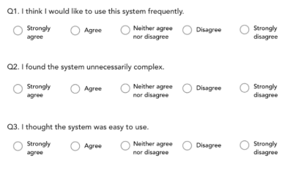

- Which scale measures “no pain at all” to “excruciating pain” – Likert, semantic, nominal, Thurstone scale

- Which of these is true about Purines- gotten primarily from diet (also synthesized in the body) -not synthesized in the body, made up of cytosine and thymine, only present in eukaryotic cells.

- What is true of Prejudice – obtaining more information about a class of people will reduce prejudice

- Q on stigma – “Courtesy stigma” is from being with someone who is stigmatised, “Felt stigma” is the feeling that one will be stigmatised by others due to a condition or experience
Stigma type | Description
Discredited and discreditable stigma | The discredited are individuals who have a stigma that is predominantly visible such as race/ethnicity, gender, or physical disability. In contrast, the discreditable are individuals who have a stigma that is predominantly concealable such as mental illness, HIV infection, or sexual minority status. Thus, these terms refer to the visual conspicuousness of the stigmatized attribute.
Felt stigma | Felt stigma (internal stigma or self-stigmatisation) refers to the shame and expectation of discrimination that prevents people from talking about their experiences and stops them seeking help
Enacted stigma | Enacted stigma (external stigma, discrimination) refers to the experience of unfair treatment by others
Courtesy stigma | The stigma that attaches to those who are merely associated with a stigmatized person

- EMI on GABA A receptor – heterodimer (NMDA), homodimer ,heteropentomer, heterotetramer, serpentine (G-protein)

- EMI on Glutamate receptor – same options as above Heterodimer (The ionotropic glutamate receptors are multimeric assemblies of four and are subdivided into three groups ( AMPA, NMDA and Kainate receptors) based on their pharmacology structural similarities.)

- EMI on types of gait seen in Neurological disorders – UMN lesion (spastic/scissor)
Gait | Description | Associated conditions
Festinating | Posture is stooped forward. Gait initiation is slow and steps are small and shuffling | Parkinson's disease
Ataxic | Gait is wide-based with truncal instability and irregular lurching steps which results in lateral veering and if severe, falling | Cerebellar disease, e.g. Wernicke's
Antalgic | Stance phase of gait is abnormally shortened relative to the swing phase, usually done to minimise pain | Lower limb trauma
Spastic (scissor or diplegic) | Rigidity and excessive adduction of the leg in swing , plantar flexion of the ankle, flexion at the knee, adduction and internal rotation at the hip, and contractures of all spastic muscles | Cerebral palsy
Steppage (neuropathic or equine) | High-stepping gait so as to prevent scraping of the toe on the ground | Foot drop
Myopathic (waddling) | A broad-based gait with a duck-like waddle to the swing phase, the pelvis drops to the side of the leg being raised with forward curvature of the lumbar spine, and a marked body swing | Proximal myopathy
Pigeon | Toe(s) point(s) inwards when walking | Structural abnormalities
Trendelenburg | During the stance phase, the weakened abductor muscles allow the pelvis to tilt down on the opposite side. To compensate, the trunk lurches to the weakened side to attempt to maintain a level pelvis throughout the gait cycle | Poliomyelitis or muscular dystrophy
Stomping | Bilateral high steppage due to lack of proprioception | Friedreich's ataxia
Magnetic | Feet seem as if magnetically attracted to the floor | Normal pressure hydrocephalus
Choreiform (hyperkinetic) | Irregular, jerky, involuntary movements in all extremities. Walking may accentuate their baseline movement disorder | Sydenham chorea, Huntington's
Sensory | In an effort to know when the feet land and its location, the patient will slam the foot hard onto the ground in order to sense it | proprioceptive loss e.g. diabetes, B12 deficiency
Hemiplegic | Unilateral weakness on the affected side, arm flexed, adducted and internally rotated. Leg on same side is in extension with plantar flexion of the foot and toes. When walking, the patient will hold his or her arm to one side and drags his or her affected leg in a semicircle (circumduction) due to weakness of leg flexors and extended foot | Stroke
*Apraxic gait- can’t initiate gait (tumors, hydrocephalus)

- Gait seen in Normal Pressure Hydrocephalus (magnetic)

- Gait seen in Cerebellar disease (ataxic)

- What part of the brain is more active in teenager than an adult *Limbic-system, amygdala (The dorsomedial prefrontal cortex (dmPFC) is part of the mentalizing network, a set of brain regions consistently engaged in inferring mental states)

- Q on maternal attachment with infant – hippocampus and limbic system, amygdala and hippocampus, hippocampus and dorsolateral prefrontal cortex

- What receptor does Cocaine act on – Dopamine Transporter, GABA, Acetylcholine
Cocaine (and modafinil, methylphenidate) directly blocks the dopamine transporter (DAT) (Massaro 2002), meaning that dopamine cannot be pumped back into the cell. This results in increased levels of dopamine in the synaptic cleft. The increase in extracellular dopamine relies primarily on normal synaptic release, which is more amenable to physiological feedback regulation.
Illicit drugs can be classified according to their mechanism of action.
Mechanism | Examples
Drugs which interfere with ionotropic receptors or ion channels | Alcohol, nicotine, benzodiazepines, ketamine
Drugs which interfere with G coupled receptors | Opioids, cannabinoids, y-hydroxybutyrate (GHB)
Drugs that target monoamine transporters | Amphetamine, ecstasy, cocaine

- Receptor acted on by use of psychedelic substances- ? NMDA, 5HT2A

- “Khat” has pharmacological effect similar to which substance – Amphetamine, Cocaine, MDMA, Ketamine

Active components (cathine, cathinone)

- Hayling Test is for – intelligence, language, executive function, verbal memory (The Hayling and Brixton tests are neuropsychological tests of executive function created by psychologists)

- Part A of trail making test assesses? – Perceptuomotor speed, intelligence, visual memory, verbal memory

- Short term memory stores information for – 10 secs, 30secs, 1 minute, 15minutes (Short-term memory (STM), also referred to as short-term storage, or primary or active memory indicates different systems of memory involved in the retention of pieces of information (memory chunks) for a relatively short time (usually up to 30 seconds)
(Echoic memory deals with auditory information, holding that information for 1 to 2 seconds. Iconic memory deals with visual information, holding that information for 1 second, Haptic- 2sec)

- Which is true about bullying – commoner in girls, bullies prefer same type of victim, commoner in primary than secondary school, bullies have less social maturity

- Q on institutional racism – not common, overt so it can be easily identified, last option likely answer?
The reasons for these findings are unclear and are hypothesized to fall into two groups:
1. Patient factors
Higher rates of mental illness has been found in Black minority groups. Black Caribbean and Black African groups in the UK have consistently been observed to have the highest incidence of psychoses, with conservative estimates suggesting a risk between four- and sixfold that of the White British population.
Perceptions of Black and minority ethnic patients being at greater risk
2. System factors
Suggestion of inherent racism within psychiatry

- Which is true about Clozapine in pregnancy – contraindicated, dose needs increasing due to enzyme induction, dose needs increasing due to increased GFR, dose reduction required due to enzyme inhibition by Oestrogens

- Test for abstract reasoning – Go/No go test, Luria test, Similarities, Clock drawing, Tower of London

- Test for executive function – Go/No go test, Luria test, Similarities, Clock drawing, Tower of London

- Which of the following organism is implicated in the development of OCD – CMV, Varicella, Staph aureus, Strept Pyogenes, Clostridium botulinum

Patients with OCD, TS, or tic disorder were more likely than controls to have had prior streptococcal infection (OR: 2.22; 95% CI: 1.05, 4.69) in the 3 months before onset date. The risk was higher among children with multiple streptococcal infections within 12 months (OR: 3.10; 95% CI: 1.77, 8.96). Having multiple infections with group A beta-hemolytic streptococcus within a 12-month period was associated with an increased risk for TS (OR: 13.6; 95% CI: 1.93, 51.0).

- Which stage is Conservation seen? Concrete operational
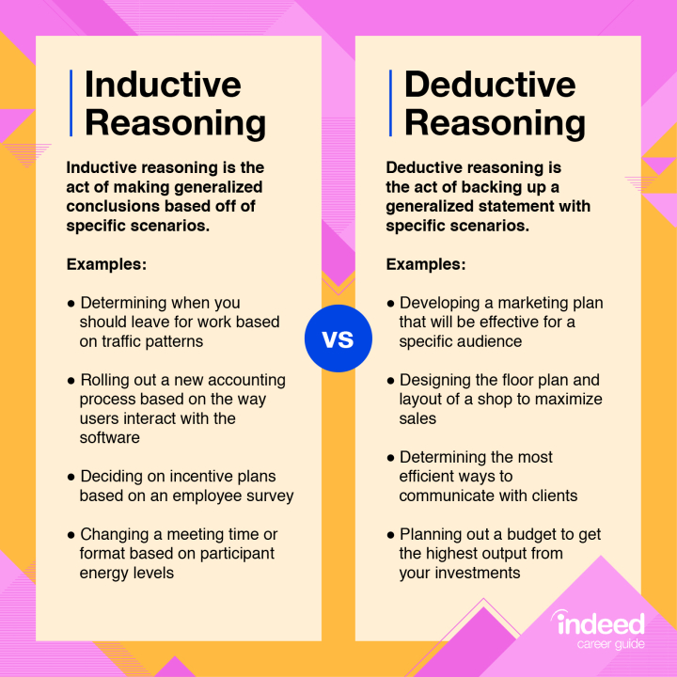
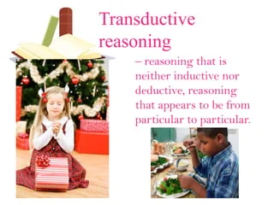

- Which stage does mid-life crises occur in? 40-45 years

Stage
Pre-adulthood stage (age 0 – 22)
Early adulthood stage (age 17 – 45)
Middle adult stage (age 40 – 65)
Late adulthood stage (age 60 – 85)
Late late adult stage (age 80 plus)

- Drug with active metabolite – sertraline
https://www.ncbi.nlm.nih.gov/pmc/articles/PMC3770982/table/T1/?report=objectonly

- A drug whose active metabolite may be an anxiogenic – Fluoxetine

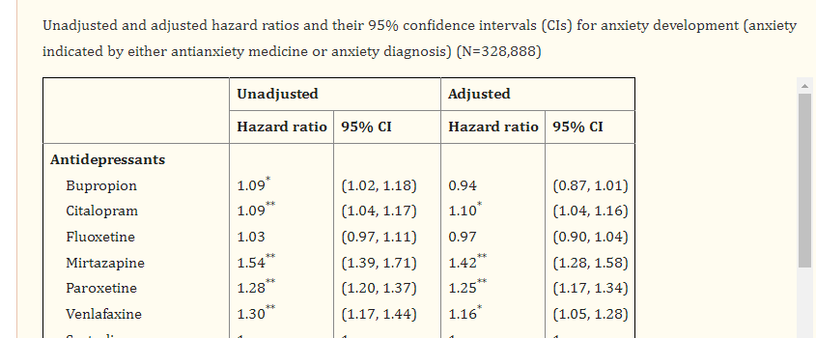

- Drug that does not act as a prodrug – Desipramine( it has an active metabolite too but is active itself too)

prodrug
/ˈprəʊdrʌɡ/
noun
- a biologically inactive compound which can be metabolized in the body to produce a drug.

- EMI - Theory that believes consequences of an action determines whether the action is good or bad – social contract, law and order, punishment

- Kohlberg’s theory that is Authority based? authority based/social order( 2nd substage of conventional)

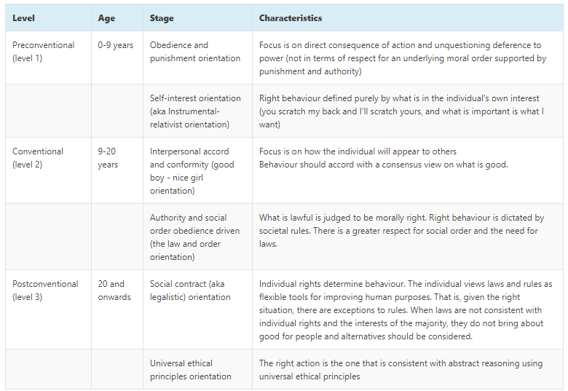

- Which of the following is true about the Big Five model of personality – personality changes with time, biological characteristics,

McCrae and his colleagues found that the Big 5 personality traits are remarkably universal. One study that looked at people from more than 50 different cultures found that the five dimensions could be accurately used to describe personality.
Based on this research, many psychologists now believe that the five personality dimensions are not only universal but that they also have biological origins. Psychologist David Buss has proposed an evolutionary explanation for these five core personality traits, suggesting that they represent the most important qualities that shape our social landscape.
Research suggests that both biological and environmental influences play a role in shaping our personalities. Twin studies suggest that both nature and nurture play a role in the development of each of the five personality traits.²
One study of the genetic and environmental underpinnings of the five traits looked at 123 pairs of identical twins and 127 pairs of fraternal twins. The findings suggested that the heritability of each personality trait was 53% for extraversion, 41% for agreeableness, 44% for conscientiousness, 41% for neuroticism, and 61% for openness.
Longitudinal studies also suggest that these big five personality traits tend to be relatively stable over the course of adulthood. One four-year study of working-age adults found that personality changed little as a result of adverse life events.
Studies show that maturation may have an impact on the five personality traits. As people age, they tend to become less extraverted, less neurotic, and less open to an experience. Agreeableness and conscientiousness, on the other hand, tend to increase as people grow older.

- Forced swim test is related to which condition (learned helplessness)– Depression, OCD, Anxiety

- Psychopathology of illusions – perception and cognitive, cognitive and conceptual, conceptual and perceptual, perceptual and signal processing(bottom up)(i hope so)

- “Top-down” theory of perception/illusion – Cognition and perception

What Is Top-Down Processing? In top-down processing, perceptions begin with the most general and move toward the more specific. These perceptions are heavily influenced by our expectations and prior knowledge. 1﻿ Put simply, your brain applies what it knows to fill in the blanks and anticipate what's next.

Top-down processing helps simplify our understanding of the world. It allows us to quickly make sense of all the information our senses bring in. As you begin to take in more information about your environment, your initial impressions (which are based on previous experiences and patterns) influence how you interpret the finer details.
This type of processing can be useful when we are looking for patterns in our environment, but these predispositions can also hinder our ability to perceive things in new and different ways.

Bottom-up processing is an explanation for perceptions that start with an incoming stimulus and work upward until a representation of the object is formed in our minds. This process suggests that our perceptual experience is based entirely on the sensory stimuli that we piece together using only data that is available from our senses.
In order to make sense of the world, we must take in energy from the environment and convert it to neural signals, a process known as sensation. It is in the next step of the process, known as perception, that our brains interpret these sensory signals.
The theory of bottom-up processing was introduced by psychologist E. J. Gibson, who took a direct approach to the understanding of perception. Rather than being dependent upon learning and context, Gibson felt that perception was a “what you see is what you get” process.¹ He argued that sensation and perception are the same things.
Because Gibson’s theory suggests that processing can be understood solely in terms of environmental stimuli, it is referred to as the ecological theory of perception.

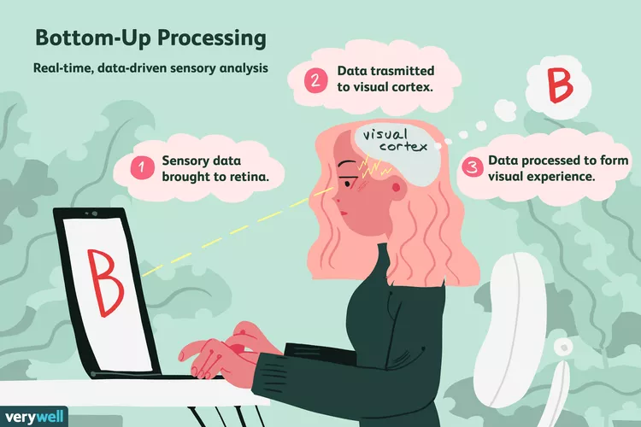

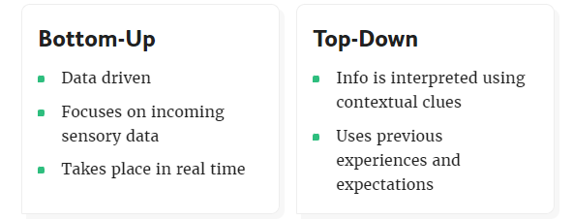

- Which is true about Agomelatine – MT antagonist, half-life of 12 hours, increases serotonin in the synapses, extensively metabolised by CYP1A2

- Drug with high affinity for Histamine (H1) receptors: Mirtazapine,TCAs

most noradrenergic is desipramine, most antihistaminergic doxepin, most inhibit serotonergic uptake Clomipramine and imipramine, most toxic in overdose Amitryptyline and dothiepin

- Anomie suicide according to Durkheim theory – lack of close relationship

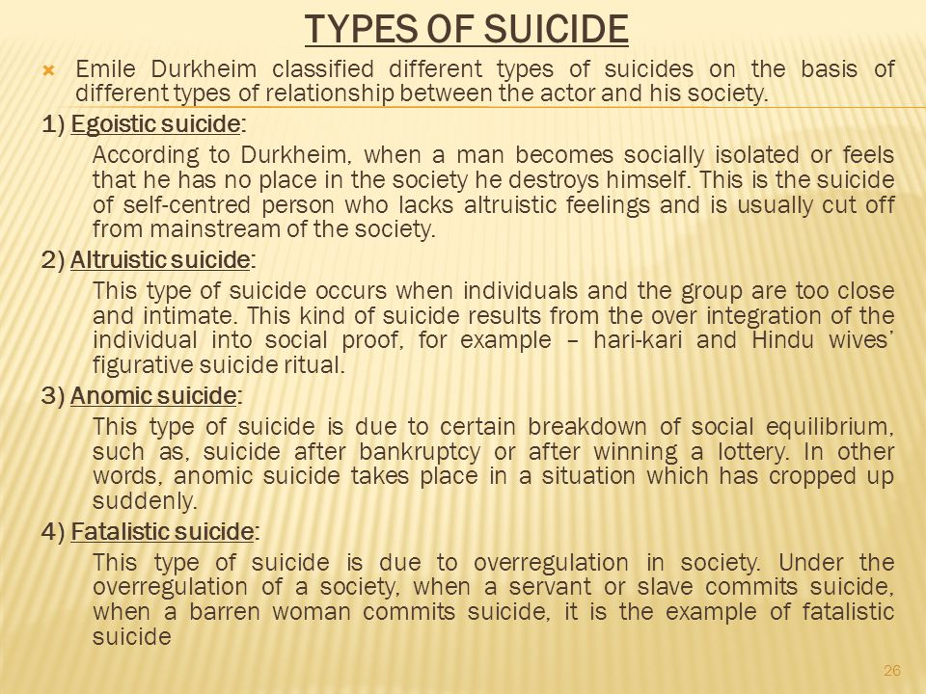

- Exaggerated and catastrophic misinterpretation of body signs and symptoms – hypochondriasis, bodily distress disorder

6C21 Body integrity dysphoria

Parent
- Disorders of bodily distress or bodily experience
Show all ancestors

Description
Body integrity dysphoria is characterised by an intense and persistent desire to become physically disabled in a significant way (e.g. major limb amputee, paraplegic, blind), with onset by early adolescence accompanied by persistent discomfort, or intense feelings of inappropriateness concerning current non-disabled body configuration. The desire to become physically disabled results in harmful consequences, as manifested by either the preoccupation with the desire (including time spent pretending to be disabled) significantly interfering with productivity, with leisure activities, or with social functioning (e.g. person is unwilling to have a close relationships because it would make it difficult to pretend) or by attempts to actually become disabled have resulted in the person putting his or her health or life in significant jeopardy. The disturbance is not better accounted for by another mental, behavioural or neurodevelopmental disorder, by a Disease of the Nervous System or by another medical condition, or by Malingering.

- Bright light therapy is used in – circadian rhythm, diurnal rhythm,

Bright Light Therapy
Bright light therapy is used to manage circadian rhythm disorders such as delayed sleep phase syndrome (DSPS), a condition which shifts the normal sleeping pattern outside what is considered the social norm. People who have DSPS generally don't fall asleep until several hours after midnight and have trouble waking up in the morning, making adhering to a normal work or school schedule difficult. However, if allowed to follow their own schedules, their quality of sleep is otherwise normal.
circadian rhythm controlled by 5HT7 and suprachiasmatic nucleus

- Which is part of the Papez circuit – insula, cingulate cortex, angular gyrus, hippocampus

James Papez described a neural pathway in the brain that mediates the process of emotion. It is referred to as the 'Papez circuit' and was one of the first descriptions of the limbic system.

The Papez circuit is bilateral, symmetrical and is located on the medial surface of the brain. It links the cortex to the hypothalamus.

Papez suggested that information about emotion passes through the hippocampus, the mamillary bodies of the hypothalamus, the anterior nucleus of the thalamus, the cingular cortex, the entorhinal cortex and, finally, through the hippocampus again thus forming a circuit.

- Psychiatric Screening tool –EPND, MADRS, Hamilton, Montgomery scale
PHQ, GHQ, HADS, (0-3)

Caseness
When a psychological rating scale is used for screening an operational definition of 'caseness' (the threshold for identifying a case) must be specified. The 'caseness' usually refers to a numerical value (cutoff) above which a respondent/ participant is considered to be a 'positive' (case).

- Advantage of research in children using a Cross-sectional method – reliability, validity, easily accessible data?

- Test of premorbid intelligence – National Adult Reading Test(misspelled words that you have to pronounce correctly), Wechsler reading

- Condition whose phenotype is related to Schizophrenia – DiGeorge, Fragile X, Prader Willi

- Autosomal Recessive condition – Autism, Fragile X, Prader Willi, Wilson’s dx

- Which is true about alcohol dependence in young people – incidence of binge drinking is lower in 18–20-year-olds, early onset of drinking is a predictor of later dependence

According to the National Institute of Alcohol Abuse and Alcoholism (NIAAA), binge drinking is “a pattern of drinking alcohol that brings blood alcohol concentration (BAC) to 0.08 percent . . . or higher.”
For adults, binge drinking means drinking about “4 or more drinks (female), or 5 or more drinks (male) in about 2 hours.” In youth and teens, binge drinking could be “only 3 drinks for girls, and 3 to 5 drinks for boys, depending on their age and size.”
The NIAAA also states that rates of binge drinking are generally high among college-aged youth aged 18-22. Among non-college students, binge drinking rates are about 27.7% and 33.0% among full-time college students

oung people who drink alcohol might be more susceptible to addiction than older adults. Teens and young adults have more intense emotions and are more sensitive to the effects of alcohol. Young people are more prone to risk-taking, which includes substance use.
Brain development does not end until young adulthood, by around age 25. Impulse control, planning, and decision-making are some of the last areas of the brain to develop.

- Which of the following do not cause delayed language development – migration, maternal smoking, lack of cognitive stimulation, large family size, maternal alcohol use

A number of risk factors are associated with delayed speech and language (Nelson 2006):-

- Family history
- Male gender
- Twins
- Lower maternal education
- Childhood illness
- Being born late in the family order
- Young mother at birth
- Low socioeconomic status
- maternal smoking
- large family size

- Pathological finding in Alzheimer’s – Alpha synuclein, Beta Amyloid, Ubiquitin

- Neurodegenerative disorder linked to Schizophrenia – Huntington, Muscular Dystrophy, Friedreich’s Ataxia???

We identified positive and significant correlation between schizophrenia and ALS at genetic (correlation 0.22; 95% CI: 0.16–0.28; p = 4.00E-04) and transcriptomic (correlation 0.08; 95% CI: 0.04–0.11; p = 0.034) levels. We further demonstrated that schizophrenia- and ALS-inferred gene expression overlap significantly in four tissues including skin, small intestine, brain cortex and lung, and highlighted three genes, namely GLB1L3, ZNHIT3 and TMEM194A as potential mediators of the correlation between schizophrenia and ALS. Our findings revealed overlapped gene expression profiles in specific tissues between schizophrenia and ALS, and identified novel potential shared genes. These results provided a better understanding for the pleiotropy of schizophrenia, and paved way for future studies to further elucidate the molecular drivers of schizophrenia.

Friedreich's ataxia (FRDA) is the most common autosomal recessive ataxia, in the vast majority of patients, due to homozygous expansion of a guanine–adenine–adenine (GAA) trinucleotide repeat in intron 1 of the frataxin gene on chromosome 9q13 [1]

- Which is a human Prion Disease – , Fatal Familial Insomnia, Progressive Focal Leukoencephalopathy, Friedreich’s Ataxia
prion diseases: BSE, Kuru, Gertsmann Straussler, vCJD, sCJD

- 2 EMI questions on Ideomotor and Ideational apraxias

Ideomotor apraxia - an inability to follow out learned tasks when given the necessary objects e.g. if given a hairbrush they try to write with it
Ideomotor apraxia (IMA) is the impaired ability to perform a skilled gesture with a limb upon verbal command and/or by imitation. It can be shown for both meaningful motor acts that do not imply objects and gestures that imply object use
Ideational apraxia - an inability to follow a sequence of actions in the correct order e.g. Take a match out a box and strike it with your left hand

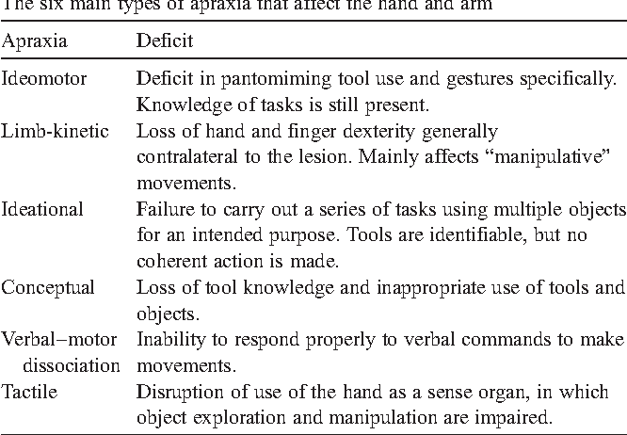
- Deep Brain stimulation is most useful for – Depression, Psychosis, ADHD

- EMI – EEG findings – 3-4Hz polyspike and slow wave (options are atypical absence seizures, juvenile myoclonic epilepsy, typical absence seizures, infantile seizure )
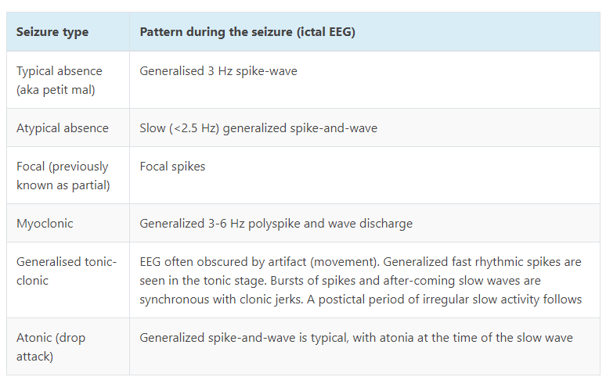

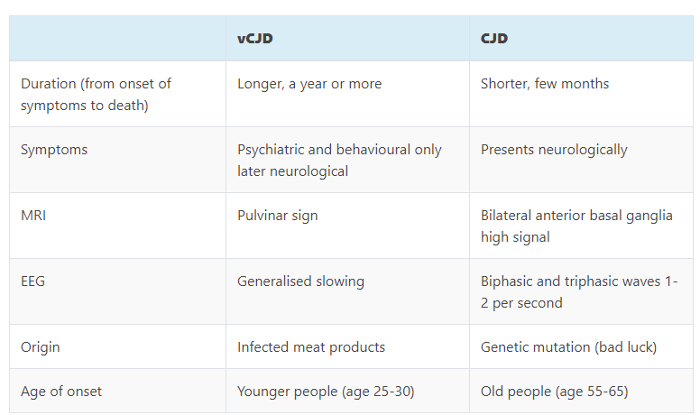

Findings on BZDs effects on sleep architecture confirm an increase in stage 2 of NREM sleep and a decrease in time of stages 3 and 4 of NREM sleep with a reduction in time of REM sleep during the nocturnal sleep
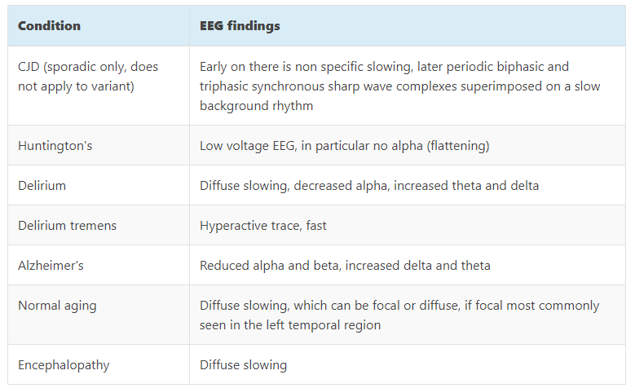

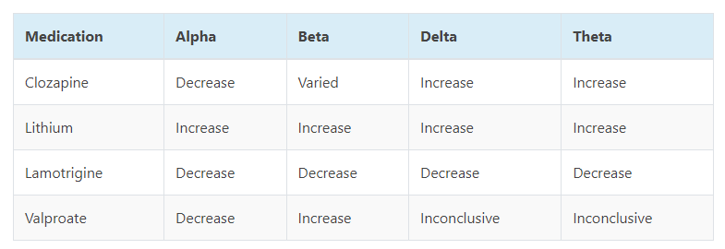
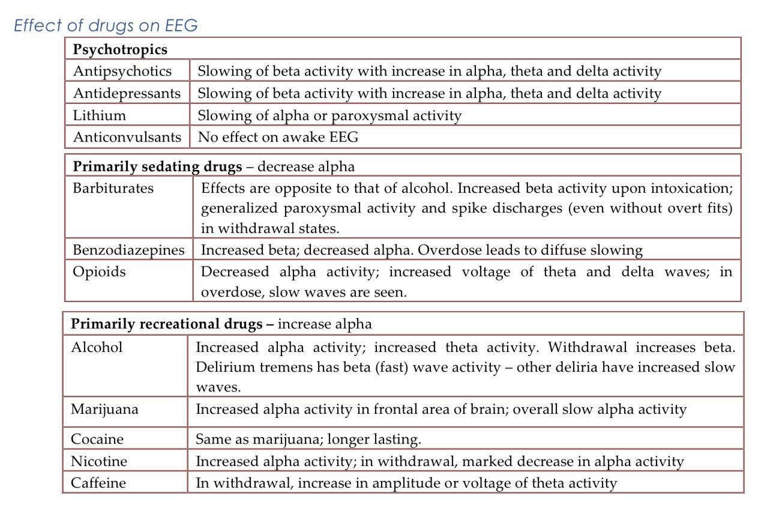

- EMI – EEG findings – 3Hz generalized slow wave ????
Encephalopathy
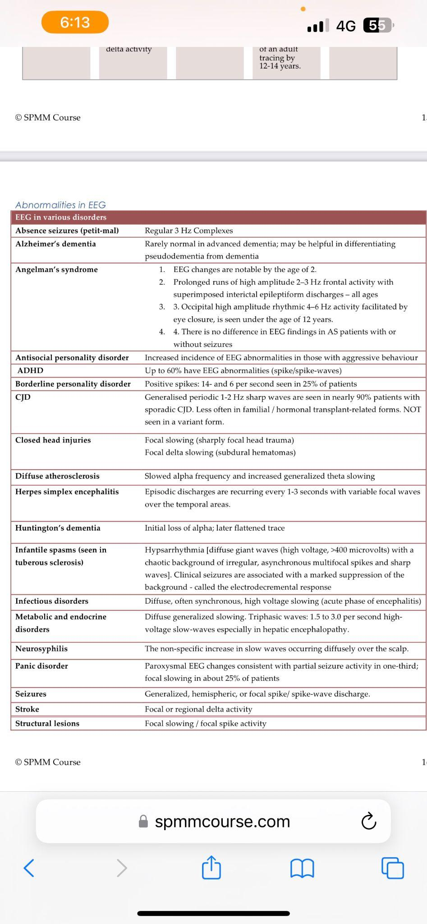

- Patient with Hyperprolactinemia on Risperidone – increased by adding Aripiprazole, mechanism is by blockage D2 Receptors in the Hypothalamus, other options???
- Definition of Neuralation – formation of neural tube

Neurulation refers to the process of transforming the flat neural plate into a neural “tube”. This process results in formation of the brain cranially, and the spinal cord caudally. It appears there are multiple initiation sites along the neural plate. Disruption of the process cranially results in anencephaly or encephalocele, whereas failure of neural tube closure caudally results in spina bifida . Day 18-21

- Memory affected in Korsakoff syndrome – Implicit memory, semantic memory, episodic memory

- Memory preserved in Normal aging – working memory, speed of processing, attention, executive function, procedural memory
- Which is true in Confabulation – Autobiographical memory is affected, other options same as previous recalls
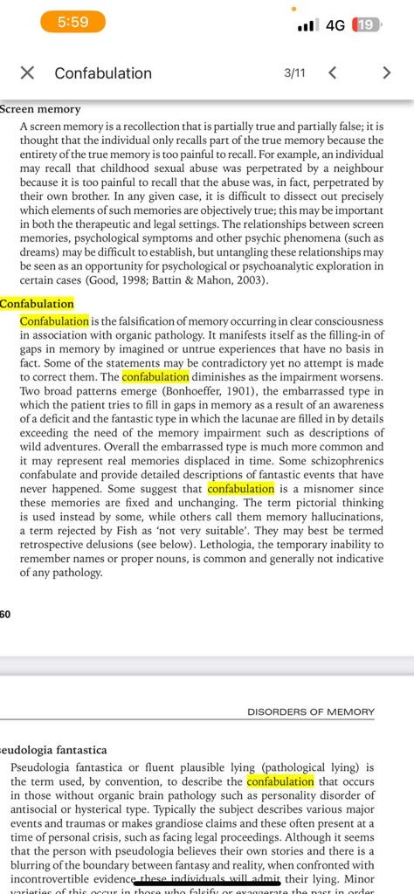

- Brain Organoid – age corresponds with second trimester fetus
- EMIs on hormones for satiety and hunger – Hormone secreted in Gut - CCK
- EMIs – Hormone secreted in Adipose tissue - Leptin
- EMIs – Hormone secreted in Hypothalamus – Neuropeptide Y

Gastrin | Secreted by cells in the stomach and duodenum | Stimulates the exocrine cells of the stomach to secrete gastric juice (a mixture of hydrochloric acid and the proteolytic enzyme pepsin)
Somatostatin | Secreted by cells in the gastric glands of the stomach | On the stomach (thus a paracrine effect) it inhibits the release of gastrin and hydrochloric acid  On the duodenum it inhibits the release of secretin and cholecystokinin  On the pancreas it inhibits the release of glucagon
Secretin | Secreted by cells in the duodenum when they are exposed to the acidic contents of the emptying stomach | Stimulates the exocrine portion of the pancreas to secrete bicarbonate into the pancreatic fluid (thus neutralizing the acidity of the intestinal contents)
Cholecystokinin (CCK) | Secreted by cells in the duodenum and jejunum when they are exposed to food | On on the gall bladder stimulating it to contract and force its contents of bile into the intestine  On the pancreas stimulating the release of pancreatic digestive enzymes into the pancreatic fluid  On vagal neurons leading back to the medulla oblongata which give a satiety signal
Ghrelin | Secreted by endocrine cells in the stomach | Acts on the hypothalamus to stimulate feeding

- Neuropeptide Y is produced by the hypothalamus and increases appetite
- Leptin is produced by adipose tissue and reduces appetite
- Ghrelin is produced mainly by the gut and increases appetite
- Cholecystokinine (CCK) is produced mainly by the gut and reduces appetite
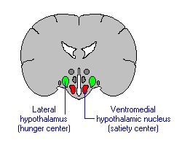

L.H (Lateral is hunger center)
lesions are opposite

Anterior helps you cool down
posterior warms up
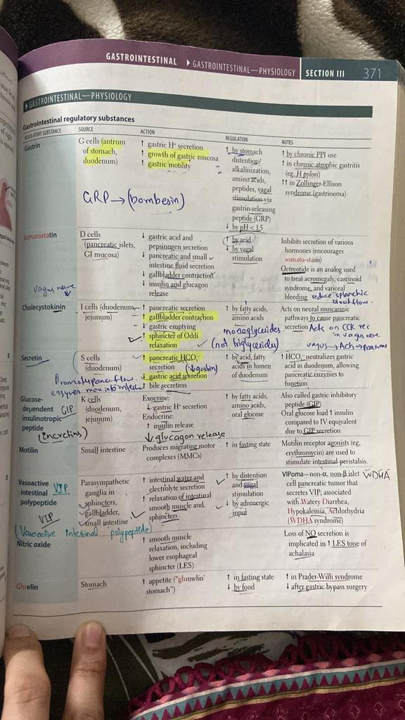
- In children with ADHD which is better to help them focus on tasks – ignore negative actions, use of small immediate rewards, use of large, delayed rewards, small immediate punishments, use of large, delayed punishment

Small-to-medium effect sizes emerged for both paradigms, confirming that participants with ADHD choose small immediate over large delayed rewards more frequently than controls. Moderation analyses show that offering real rewards in the SCP almost doubled the odds ratio for participants with ADHD.

- HIV-associated neurocognitive disorder in patient who has been on ART for a long time, what is seen? – High CD4 count (Initially low and later Normalize after ART), High CD8 count (not normalize even with ART), Neuronal loss

During the ART era, observations of cortical,10 subcortical, gray matter,9 and white matter10 atrophy have continued, with decreases in cortical gray matter and brain parenchymal volume observed even in the first year of HIV infection
Studies have reported that individuals initiating ART at higher counts have their CD4+ cell count return to nearly normal or normal (>500 cells/mm3) than those who initiated at lower counts (< 200 cells/mm3)
CD8+ T-cell counts are elevated during HIV infection and do not normalize despite long-term cART. Low CD8+ T-cell counts are associated with increased AIDS-related mortality.
Untreated HIV infection drives the CD4/CD8 ratio lower. In some populations, initiation of ART can increase the ratio; however, early and continuous treatment is essential.
normal CD4/CD8 ratio is greater than 1.0, with CD4 lymphocytes ranging from 500 to 1200/mm 3 and CD8 lymphocytes ranging from 150 to 1000/mm 3. If your ratio is higher than 1, it means your immune system is strong and you may not have HIV. If your ratio is less than 1, you may hav
You may have HIV

HIV does not directly invade nerve cells (neurons) but puts their function at risk by infecting cells called glia that support and protect neurons. HIV also triggers inflammation that may damage the brain and spinal cord (central nervous system) and cause symptoms such as: Confusion and forgetfulness.
Macrophage and microglia in brain
peripheral CD4 cells

Cells least likely to be affected by HIV in brain
Neurons
Theoretically all cells are affected including astrocyte, oilgodendrocyte, perivascular macrophages, microglia and even neurons

- Definition of avoidant/restrictive food intake disorder
(Not preoccupied by weight just excludes certain food groups from diet)

- What is used in T2 weighted MRI – Calcium, water, haemoglobin
T1-weighted MRI enhances the signal of the fatty tissue and suppresses the signal of the water. T2-weighted MRI enhances the signal of the water. Consideration of all the information provided by these modalities is conducive to MRI image analysis and diagnosis.

- Ion implicated in Schizophrenia??? – Calcium, potassium

Potassium channels are widely distributed in the CNS and thought to have a role in modulating electrical excitability in neurons, regulating action potential duration and neurotransmitters release. Therefore, it is no surprise that some potassium channel genes have been considered candidate for susceptibility to schizophrenia.
KCNN3, encoding the small conductance calcium-activated potassium channel SK3, is located at 1q21, a region reproducibly and strongly implicated in schizophrenia.

- What acts as intracellular second-messenger system – Calcium, potassium
Calcium, IP3, DAG, Cyclic AMP,
- EMI – family members ganging up against one family member – triangulation (Triangulation is when a toxic or manipulative person, often a person with strong narcissistic traits, brings a third person into their relationship in order to remain in control.) , detouring Detouring scale assesses the degree to which the parents form an alliance against the child in a way that functions to create distance between themselves and the child and increase closeness in their own relationship scapegoat syndrome.(Detouring occurs when parents, rather than directing anger or criticism toward each other, focus the negativity on the child and the parent-child conflict thus serves to distract from the tension in the marital subsystem), circular causality (a sequence of causes and effects that leads back to the original cause and either alters or confirms it, thus producing a new sequence, as in a feedback loop), ((Enmeshment is a trait of family dysfunction that involves poorly defined or nonexistent boundaries, unhealthy relationship patterns, and a lack of independence among family members).)enmeshment .
- EMI – Q on being aware that people’s interaction are influenced by each other which in turn are influenced by others - Circular causality e.g (From a circular causality perspective, a husband and wife present in therapy with same concern regarding communication issues. The therapist begins to ask questions that focus on what is happening in the system that makes the communication pattern persist), triangulation, detouring, enmestment (e.g This often happens on an emotional level in which two people “feel” each other's emotions, or when one person becomes emotionally escalated and the other family member does as well. A good example of this is when a teenage daughter gets anxious and depressed and her mom, in turn, gets anxious and depressed)
- Q on Rogerian (person centered therapy) – reflecting on how intended outcomes are affected by current behaviours – Cognitive Therapy, Motivational interview (Motivational interviewing is a counseling method that helps people resolve ambivalent feelings and insecurities to find the internal motivation they need to change their behavior. It is a practical, empathetic, and short-term process that takes into consideration how difficult it is to make life changes), Cue therapy
- Q on Alcohol addiction - Cue therapy
- What setting has the highest likelihood of obedience, Presence of:- legitimate authority in prestigious setting, legitimate authority in mundane setting, uniform-wearing person in mundane setting, telephone instruction from legitimate authority
Milgram found that subjects were more likely to obey in some circumstances than others. Obedience was highest when:

Commands were given by an authority figure rather than another volunteer
The experiments were done at a prestigious institution
The authority figure was present in the room with the subject
The learner was in another room
The subject did not see other subjects disobeying commands
In everyday situations, people obey orders because they want to get rewards, because they want to avoid the negative consequences of disobeying, and because they believe an authority is legitimate. In more extreme situations, people obey even when they are required to violate their own values or commit crimes. Researchers think several factors cause people to carry obedience to extremes:

People justify their behavior by assigning responsibility to the authority rather than themselves.
People define the behavior that’s expected of them as routine.
People don’t want to be rude or offend the authority
- People obey easy commands first and then feel compelled to obey more and more difficult commands. This process is called entrapment, and it illustrates the foot-in-the-door phenomenon.

- Infected neuron with cytokines in the surrounding milieu is suggestive of – Necrosis
Apoptosis is described as an active, programmed process of autonomous cellular dismantling that avoids eliciting inflammation. Necrosis has been characterized as passive, accidental cell death resulting from environmental perturbations with uncontrolled release of inflammatory cellular contents

- When does stranger anxiety develop? – 3 months, 9 months, 6 years, 12 years

nitially, babies show a positive response to strangers (between 14-18 weeks), this is normally replaced by stranger anxiety at around 8 months.

When an infant is separated from their main carer it is common for them to become anxious (aka separation anxiety). 'Separation anxiety' is most common when an infant is 10 - 18 months and usually diminishes by year three.

- Neurotransmitter which is easily disintegrated – Acetylcholine (ACHE present right in synaptic cleft), Dopamine, Serotonin
- Disulfiram acts on what ? – Aldehyde dehydrogenase (Alcohol dehydrogenade is rate limiting step)
- Q on Imprinting???

mprinting is a term used to describe the phase-sensitive attachment seen in some animals and in humans.

The classic demonstration of imprinting was performed by Konrad Lorenz. He was working with Greylag geese, and showed that imprinting behaviour consists of three parts:-

At some time after hatching the gosling will start to follow the first conspicuous object it sees (the following response)
After following the object for a number of hours the hatchling will start to develop an attachment for the object
Once an animal has imprinted, it develops a sexual preference, when it is mature, for the object on which it imprinted

Lorenz also observed the following:-

Imprinting is rapid (sometimes occurring within minutes)
Imprinting is unreinforced (no reinforcer is necessary for the response to occur)
Imprinting occurs during a clearly defined period (known as the critical period)
Imprinting is irreversible

- Which neuroimaging modality is more …… - PET, SPECT, fMRI, 11c labelling approach
PET and SPECT scans use radiopharmaceuticals to create 3D images, but the tracers used are differently. SPECT scans measure gamma rays, and the radiotracers used with PET scans produce small particles called positrons.

- Which neuroimaging technique to detect 70% D2 occupancy DAT scan……- same as above
- Potent inhibitor of DAT – Fluoxetine, Sertraline, Citalopram, Trazodone (weak inhibitor), Vortioxetine
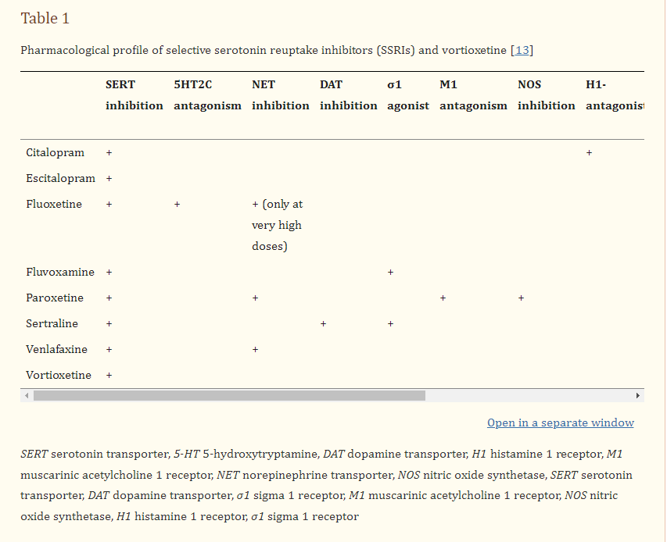
- A man who migrated to another country has adopted the new culture while maintaining his culture of origin – Integration, Assimilation (New culture adopted and home culture forgotten), Marginalisation (No culture present), Separation (Only home culture)
- What bias is expected if individuals are asked to fill a self-questionnaire about their personality traits – Social desirability, factor analysis

Social desirability bias is the tendency to underreport socially undesirable attitudes and behaviors and to over report more desirable attributes. One major theory of social desirability bias by Paulhus (1984) suggests two components

- A child is given a star sticker every time he takes his medicine, after collecting 10 stickers he can get a fruit. What type of reinforcement is achieved with the fruit? – primary reinforcement, positive conditioning, secondary reinforcement
What is a token economy? A token economy is a behavior-management system in which targeted behavior is reinforced with tokens (secondary reinforcers) and later exchanged for rewards (primary reinforcers). The method is based on operant conditioning and is widely used in elementary classrooms​
- Which of these is part of the basal ganglia? Putamen, stria terminalis LPGP (lentiform = putamen + globus pallidus) (Striatum= caudate + putamen)
- Which of these is a Metabotropic receptor? 5HT2A, AMPA, GABA A, NMDA
- After how many half-lives is a drug eliminated? – 2,3,4,5,10
- Erickson’s stage where a child can understand the pain of another child – Formal operational, Preoperational, Sensorimotor (In concrete operational stage, egocentric thought is replaced by operational thought)
- Question about auto-immune encephalitis and the antibodies of this? NMDA, DPPX, IGCLON.

